ENGLISH
- With increasing confidence, spoken language is fluent and clear, within in a range of situations.
- Explore different voices in my reading.
- Practice and experiment with the use of tone and volume.
- Develop ability to talk for a range of purposes.
- Ask questions and respond appropriately within group discussions making relevant comments to the suggestions of others.
- Punctuate speech accurately in writing.
- Begin to use a comma to mark a pause in a complex sentence.
- Plan to use paragraphs to group related material.
- Use a variety of sentence openers to add interest.
- Use the features of non-narrative material.
- Propose changes to grammar and vocabulary to improve consistency including the accuracy of pronouns.
- Discuss and record ideas.
- Compose and rehearse sentences orally improving them through a range of varied and rich vocabulary and range of sentence structures.
- Begin to identify the differences between a wider range of non-fiction text types and fiction texts.
- Recognise presentation devices,
- When prompted, justify and elaborate on opinions and predictions.
- Quote directly from the text to support thoughts and discussions.
Geography
- Recognise what a rainforest is and locate the world’s rainforests on a map
- Recognise the different layers of life in a rainforest
- Recognise the features that make up a rainforest
- Describe and explain the impact of the deforestation of the rainforests
- Explain the importance of the Amazon Rainforest
MUSIC
- To notice and explore the way sounds can be combined and used expressively.
- Listen to different types of composers and musicians.
FRENCH
- Name, recognise and remember up to 10 fruits in French.
- Attempt to spell some of these nouns with their correct article/
- determiner.
- Ask somebody in French if they like a particular fruit.
- Say what fruits we like and dislike in French.

Computing: Photo Editing
- Change the composition of an image by selecting parts of it.
- Identify how an image has been retouched.
- Combine parts of images to create new images.

RE: Islam
How do festivals and worship show what matters to a Muslim?

MATHS
Number - Multiplication and Division
- Find factor pairs
- Multiply and divide by 10 and 100
- Reasoning about multiplication
- Multiply three numbers
- Efficient multiplication
- Scaling
- Correspondence problems
- Multiply up to a 3-digit number by a 1-digit number – no exchange
- Multiply up to a 3-digit number by a 1-digit number – with exchange
- Related calculations – multiplication and division
- Divide by a 1-digit number – flexible partitioning
- Divide up to a 3-digit number by a 1-digit number – no exchange
- Divide up to a 3-digit number by a 1-digit number – with exchange
- Divide up to a 3-digit number by a 1-digit number – with remainders

Measurement – length and perimeter
- Measure in centimetres and millimetres
- Measure in kilometres and metres
- Kilometres, metres, centimetres and millimetres
- Equivalent lengths
- Add and subtract lengths
- What is perimeter?
- Calculate perimeter
- Perimeter of rectilinear shapes
- Calculate perimeter of rectilinear shapes
- Perimeter of polygons

Number Fractions 1
- Understand denominators
- Compare and order unit fractions
- Understand numerators
- Understand the whole
- Fractions on a number line

Under The Canopy
Why should we protect the rainforest?
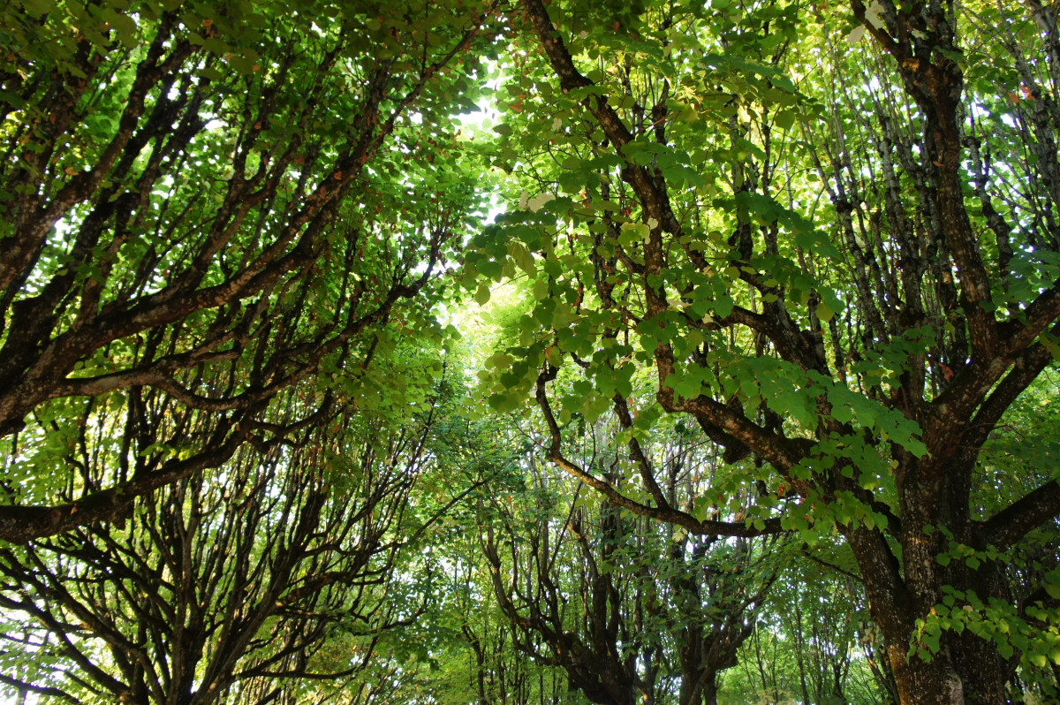

Term 3 - Year 3 and 4

SCIENCE – Sound
- Identify how sounds are made, associating some of them with something vibrating
- Recognise that vibrations from sounds travel through a medium to the ear
- Find patterns between the pitch of a sound and features of the object that produced it
- Find patterns between the volume of a sound and the strength of the vibrations that produced it
- Recognise that sounds get fainter as the distance from the sound source increases.

COMPUTING
- PowerPoint skills and presentation.
- Online safety.
- File saving and retrieval.

P.E.
Dance: Movements/Patterns
Gymnastics: Jumping/Apparatus
Art:
- Learn about the artist, Henri Rousseau and evaluate his paintings
- Use sketchbooks to record and sketch observations from real life and photographs
- Explore tonal variation
- Create a composition for a painting inspired by Henri Rousseau
PSHE:
Belonging to a Community
- The value of rules and laws; rights, freedoms and responsibilities.
Media Literacy and Digital Resilience
- How the internet is used; assessing information online.
WWO:
- active listening: remembering
- listening (nonverbal)
- taking turns talking (not interrupting)

