

99 Club

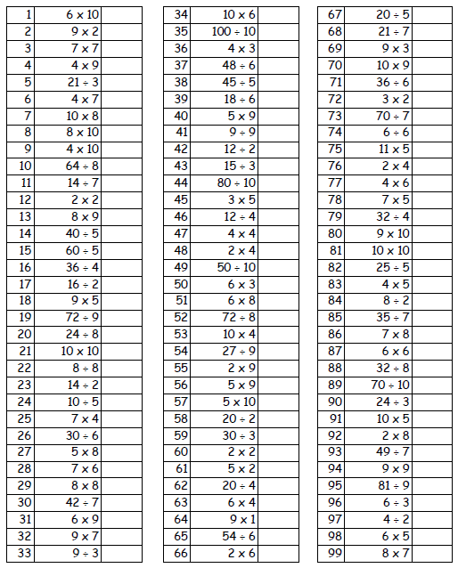Name:________________________ Date:__________________