Homework activities are intended to be as open ended as possible, allowing the children to reflect on their learning in class in a creative way
and for the children to make their own decisions on how to collect, record and present their home learning.

Each week your child will be expected to complete a homework grid task. They can answer the question or complete the task in their own
preferred way on one or two pages in their homework book. Here are some ideas of how children might
approach learning grid activities:
Termly Reminders
- PE days are Monday and Wednesday.
- Please ensure children have a named water bottle in school.
- We encourage children to read for at least 10 minutes each day from home.
- Children must complete their homework task each week.

● Drawing, colouring, sketches, labelled diagrams, artwork- painting, collage, 3D constructions
● Cooking with photographs or explanations
● Take photographs or even videos of their work
● Use the internet as a resource
● Tables, charts and grids
● Writing fiction, poems, descriptions
● Writing non-fiction-report, diary, letter, journal, newspaper report, e mail, leaflet, debate or explanation
● Invitations, postcard
● Your child can include objects or resources or references to them.

We hope you have fun learning

Option 1 – Write an acrostic poem for a planet of your choice. Research the planet to make sure the words and phrases you choose describe the planet.  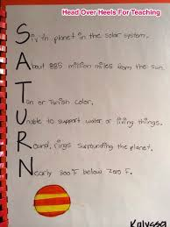  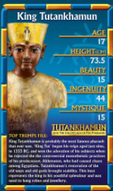 | Option 2 – Research how far it is to each planet from Earth (in miles) and present this data in a bar chart.  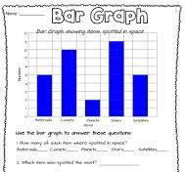 | Option 3 – Write a set of instructions telling an alien how to pretend to be human and not get caught during a day at school.  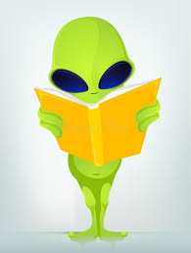
Option 4 – Create a poster showing the names and relative sizes of the planets in the solar system.  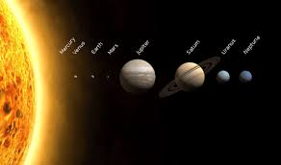 | Option 5 – Draw a cartoon strip about an alien landing on Earth for a day. How would they spend their day? What would they think of human beings?  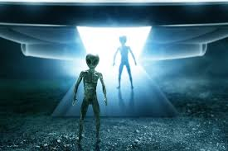 | Option 6 – Design a job advert for an astronaut. Think carefully about the skills required.  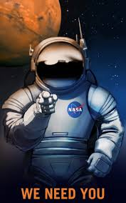
Option 7 – Make your own 3D alien! You can use whichever materials you choose.  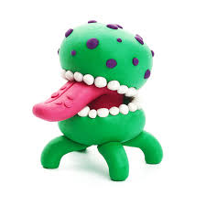  Option 7 – Design | Option 8 – Find out about the zodiac star constellation for your birth date. Could you draw it and record some facts about it?  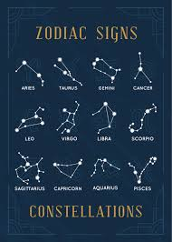 | Option 9 – Free choice!  