Homework activities are intended to be as open ended as possible, allowing the children to reflect on their learning in class in a creative way
and for the children to make their own decisions on how to collect, record and present their home learning.

Each week your child will be expected to complete a homework grid task. They can answer the question or complete the task in their own
preferred way on one or two pages in their homework book. Here are some ideas of how children might
approach learning grid activities:
Termly Reminders
- PE days are Monday and Wednesday.
- Please ensure children have their PE kit along with a named water bottle in school.
- We encourage children to read for at least 10 minutes each day from home.

● Drawing, colouring, sketches, labelled diagrams, artwork- painting, collage, 3D constructions
● Cooking with photographs or explanations
● Take photographs or even videos of their work
● Use the internet as a resource
● Tables, charts and grids
● Writing fiction, poems, descriptions
● Writing non-fiction-report, diary, letter, journal, newspaper report, e mail, leaflet, debate or explanation
● Invitations, postcard
● Your child can include objects or resources or references to them.

We hope you have fun learning

Option 1 – Create your own scrapbook or mood board reflecting what makes  YOU A CHAMPION!  This can be added to with your achievements, how you felt, who has helped you along the way and any inspirational quotes. | Option 2 – Create a Word Cloud by clicking on the link below and adding in words associated with you! http://www.wordclouds.co.uk  What are you good at? Who is important to you? What qualities do you have? What skills do you possess?  Try to use at least three or four new words (by finding synonyms) to add to your vocabulary.  Play around with how you want the design to look and then save the image. If you are unable to access the website, you can hand draw your Word Cloud. | Option 3 – the song Space Oddity by David Bowie http://mrwreads.blogspot.com/2012/03/wonder-part-two-via.html is referenced in the book Wonder. Listen to the song. Choose a song that represents you. Take the parts of the song that you think best describe you and create a piece of artwork using these words.
Option 4 – Make a pictoword, like the examples below, which celebrate everything that’s AMAZING about YOU! Be as creative as you wish, you can use any form of art media you wish.  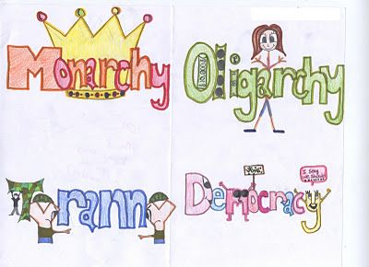 | Option 5 – When given the choice between being right or being kind, choose kind.  What does this mean? Create a poster, either digitally or by hand to promote the message: Choose kind. | Option 6 – Write a poem all about you. It does not have to rhyme but remember to use poetic devices such as: similes, metaphors, personification, onomatopoeia, alliteration, rhyming (if you want to), and rhythm.
Option 7 – In keeping with our topic ‘Marvellous Me’, design and make a cake or other desert that celebrates you. Include photos of the creation process, ready to share with the class.  Option 7 – Design | Option 8 – Create a ‘Choose Kind’ sign that reflects your feelings and thoughts on what it takes to be kind. Each letter could stand for a trait or value that you think represents kindness. See example: | Option 9 – Use books or the internet to research acts of kindness. They could be great deeds that people have done. They could also be small things, that make a big difference. Present the information however you wish, ready to share with the class

