

33 Club

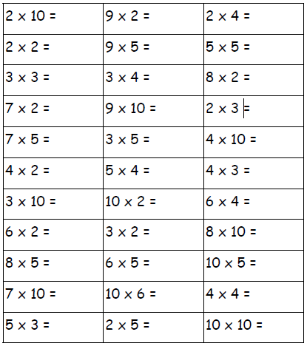Name:___________________ Date:________